Use Case Diagrams:

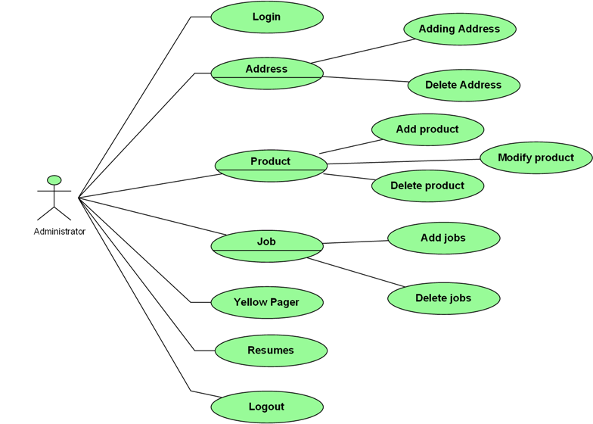

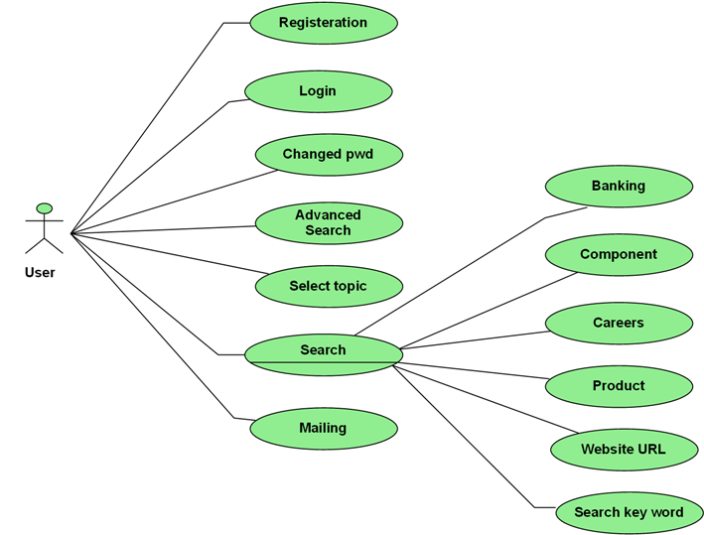

Class Diagram:

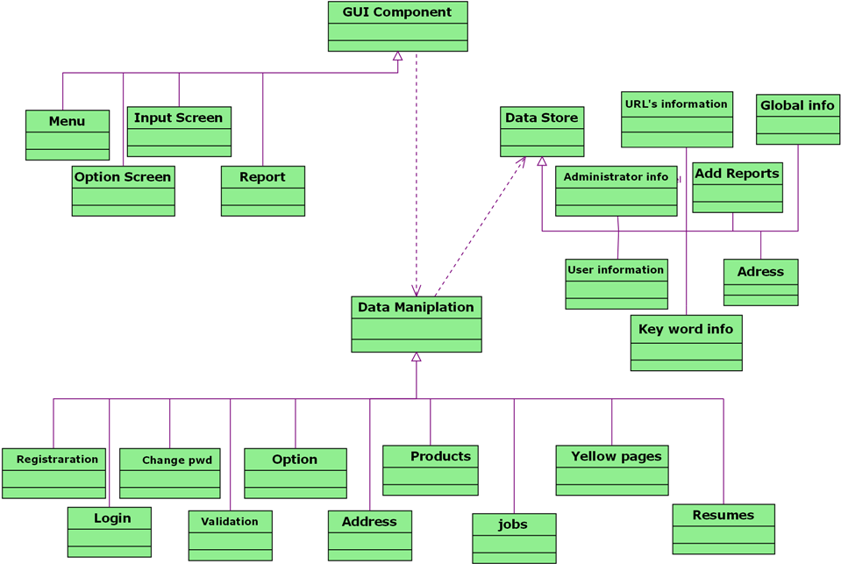

Activity Diagram:

Branch
Details
Login

Dealer
Validatee
Consign
ments

Admin
Deliveries

Dispatches

Admin
Options
Receivers

Jobs
Products
Yellow Pages

Addresses
Resumes

Activity Diagram:

Topicwise
Search

Advanced
Search
Normal
Customer
Options

View
Products

View
Jobs

Yellow Pages

Register

Yellow Pages

Topicwise
Search

View
Products

Login
Advanced
Search

SignedCustomer
Validatee
Customer
Options

View
Jobs

Post
Resume

Sequence Diagram:

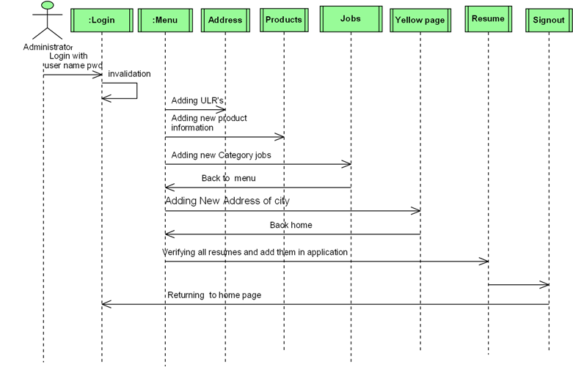

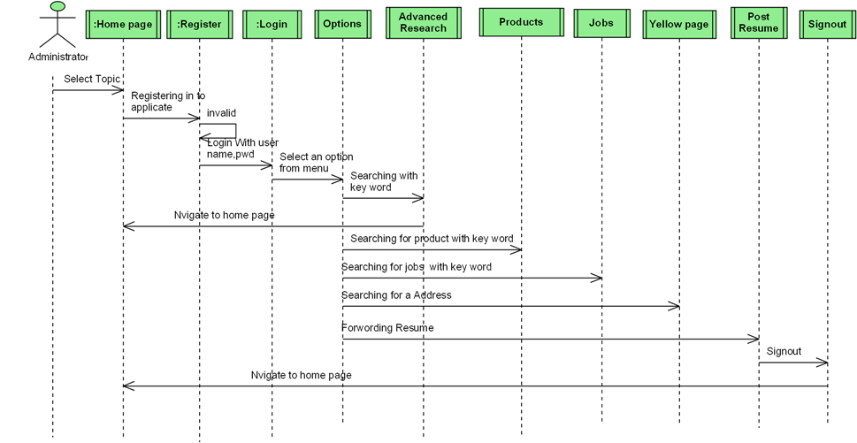

State Diagram for Administrator:

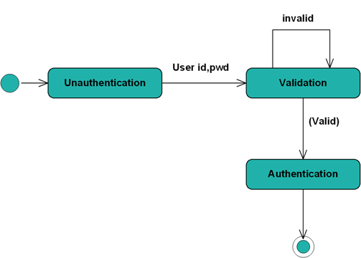

State Diagram for User:

